Mini project
Securing a basic website and Implementing basic security measures

- Local server basic interface
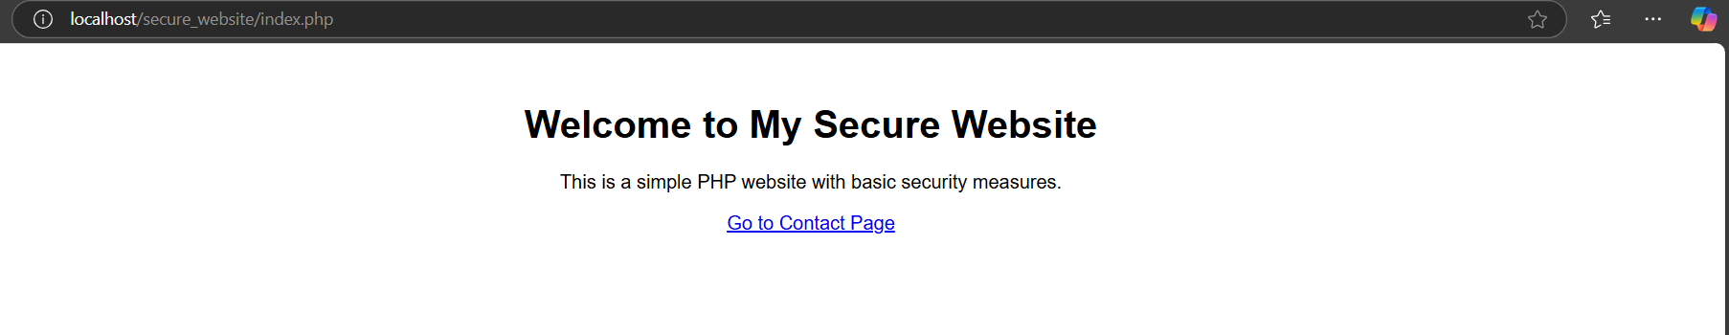

1.Cross Site Scripting Prevention (xss)
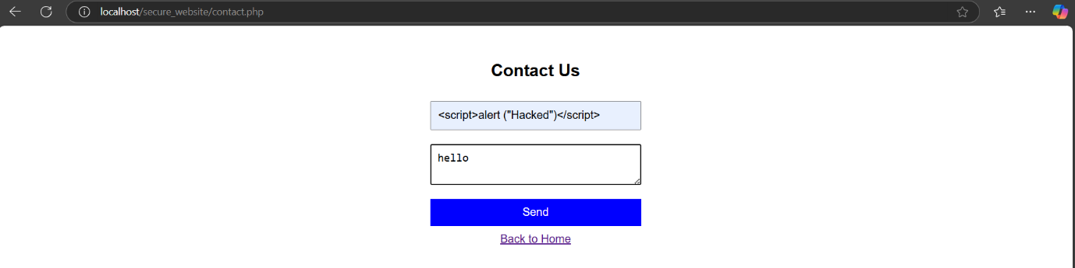

- Before
using “htmlspecialchars()” to filter scripts
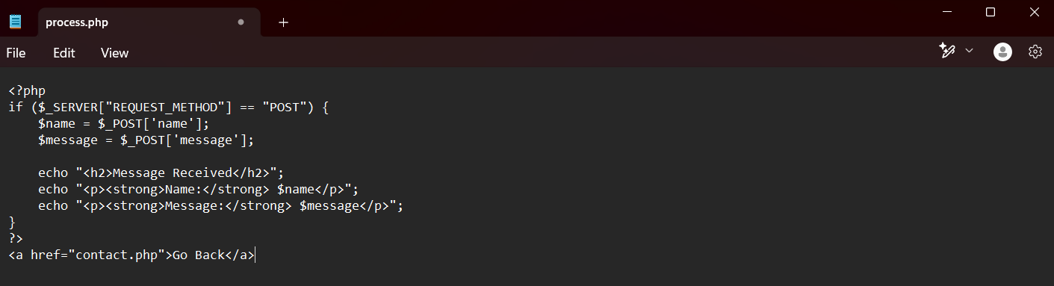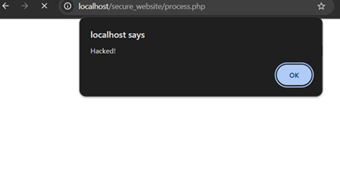
- After
using “htmlspecialchars()” to filter scripts
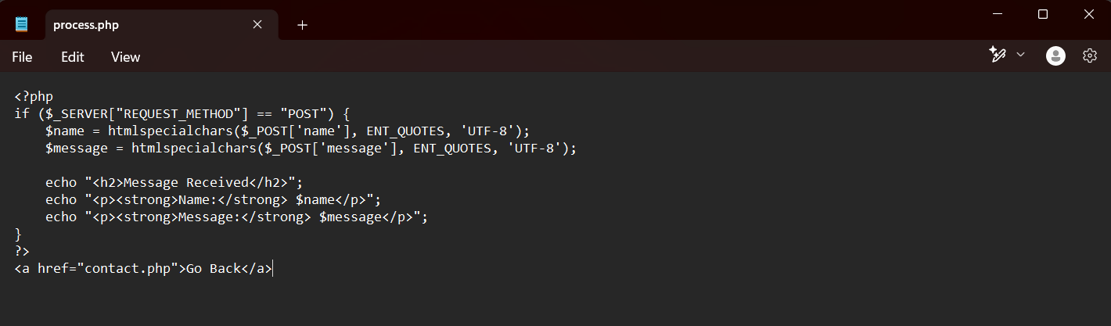

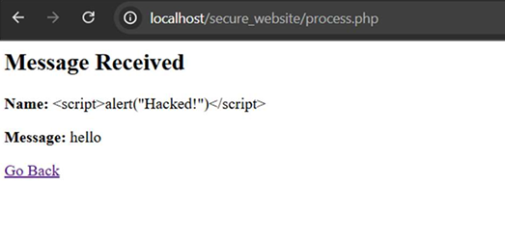
- 2.Implementation Input Validation
This will make sure that only valid input is accepted.
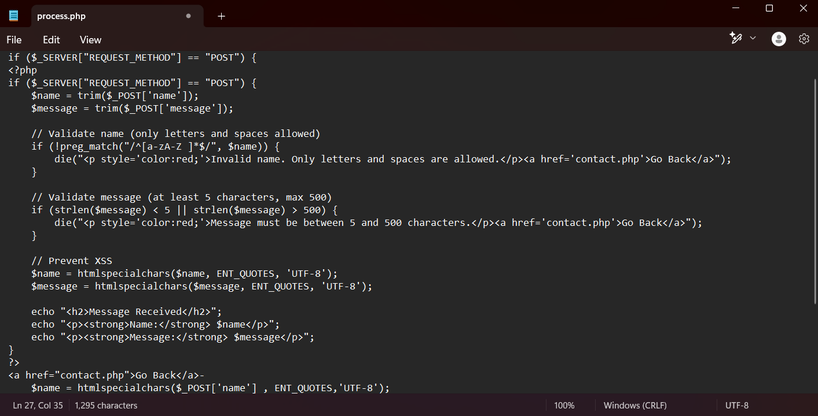

- Before
It also accept numbers and special characters in the name input 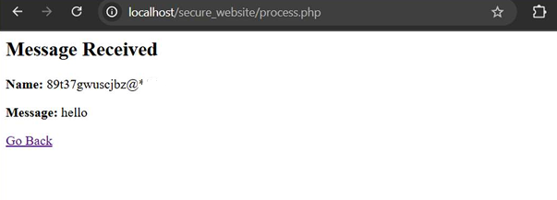
- After
Showing invalid input when taking number in input
